Article Title – Title style

Author name(s), Institution(s)

Contact email to corresponding author – Author style

Abstract – Heading Abstract style

Replace this text with your abstract – Abstract style. The abstract should be no longer than 300 words. The abstract should provide an overview of the full paper and should highlight the contribution which is made to the relevant body of knowledge. The abstract which was accepted for the conference can be pasted into this section and formatted appropriately using the Abstract style.

Key Words (Provide between 3 and 5 key words): Key word 1, Key word 2, Key word 3 – Keywords style

# Heading Level 1 (All capital letters, Times New Roman, 10 point font and Bold) – Heading 1 STYLE

Please replace this text with your main text – Normal style. The font type should be Times New Roman size, 9-point font, fully justified, with single line spacing.

Please leave a single line space between paragraphs – This is already set up in the Normal style. Do not indent subsequent paragraphs. Please use the built-in formatting styles where possible. These have been set up to support the formatting of the final proceedings. The formatting has been strategically designed to facilitate authors who wish to subsequently revise their articles for a journal submission based on feedback received at the conference.

The article should have a maximum word count of 3000 words. This includes only the main body of text and does not include the author information, abstract, key words, text in tables, figure and table captions, and the reference list. Note that full papers should not exceed 4000 words in total.

## Heading level 2 (Times New Roman, 9-point font, bold and italics) – Heading 2 style

This text is written using the “Normal” style.

## Language and formatting

Papers should be written in American or British English.

Formatting of tables, figures, references, etc. should follow the American Psychological Association’s guidelines, 7th edition (APA, 2020).

### Heading level 3 (Times New Roman, 9-point font, italics) – Heading 3 style

Please only use a maximum of three heading levels using the built-in styles. Numbering is added automatically if the styles are used.

# Article Layout

The appropriate sections for articles will vary depending on the nature and intent of the article. In general, authors should aim to provide the following information:

1. Introduction: This section should provide a broad overview of the research area and serves to contextualise your research within it.
2. Literature Review: +A and relevant frameworks are critiqued. It should culminate with the presentation of the need for the research presented in the current article.
3. Methodology: This section should provide explicit details on the method used within the current study. Sub sections may include details of the approach, participants, methodological tools, and the implementation.
4. Results: This section should provide an objective overview of the results generated from the study.
5. Discussion: This section should present the authors insights into the significant of the results from the current study. The final paragraph may serve as a conclusion should the authors wish however a separate concluding section may be included.

Numbered lists should be listed using the List (numbered) style, which automatically adds lower case roman numerals and hanging indentation.

1. Like this. Look how this very long text is indented in a sound way with beautiful line-wrapping.
2. And like this for a shorter one.

And non-hierarchical lists should use List (bulleted) style,

* Like this
* And like this

If the authors are presenting a position paper or a discussion paper the above sections may not be suitable. In such cases care should be taken to present the article in a series of coherent sections.

Quotations of 40 words or more should be treated as block quotations (Quotation style):

Technological systems are essentially products of industrial society but as we enter a post-industrial era in the early 21st century such systems will only increase in importance. Ours is a networked and systemic society, being increasingly permeated by pipes, cables, servers, automation and signals. (Hallström, 2022, p. 235)

# Tables and figures

Please label all tables and figures appropriately and follow the APA (2020, pp. 195–250) guidelines where possible. Examples are shown below. For tables, please avoid vertical lines where possible.

## Sample tables

Table 1 – Caption table figure numbering style

A Sample Table with Aligned Numerical Values – Caption table figure text style

|  |  |  |  |
| --- | --- | --- | --- |
| Name | Integer value | Float values | |
|  |  | First | Second |
| Alpha | 34 | 16.5 | 19.26 |
| Beta | 1 | 413.2 | 42.42 |
| Gamma | 4711 | 0.006 | 0.123 |
| Note: A left-aligned note to the table. Table cells use the Table body text style, with manually added number formatting- | | | |

Table 2

Sample Table Caption

|  |  |  |
| --- | --- | --- |
| Cohort | Self-reported status | Status mode |
| 1st year | Good | 19 |
| 2nd year | Good | 22 |
| 3rd year | Great | 23 |
| 4th year | Fantastic | 139 |

## Sample figure

Figure – Caption table figure number style

Sample Figure Caption –Caption table figure text style

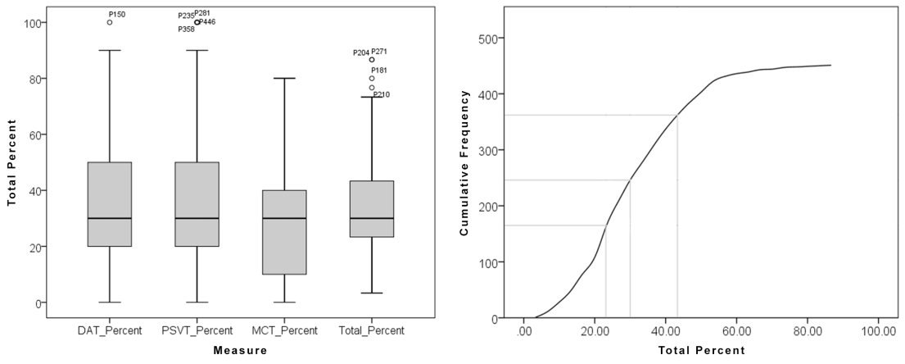

# References

Please list all references in this section in alphabetical order. Please adhere to the APA (2020, pp. 281–309) referencing system and use the References style. Typical examples are provided below.

American Psychological Association. (2020). *Publication Manual of the American Psychological Association*. 7th edition. American Psychological Association.

Davies, S. (2022). Managing curriculum change. In A. Hardy (Ed.), *Debates in design and technology education* (2nd ed., pp. 151–162). Routledge.

Hallström, J. (2022). Teaching and Learning About Technological Systems: A Research Synthesis. In J. Hallström & P.J. Williams (Eds.), *Teaching and Learning about Technological Systems: Philosophical, Curriculum and Classroom Perspectives* (pp. 235–249). Springer. https://doi.org/10.1007/978-981-16-7719-9_12

Hardy, A. (2015). *What’s D&T for? Gathering and comparing the values of design and technology academics and trainee teachers.* Design and Technology Education: An International Journal, *20*(2), 10–21.

Hardy, A., Dunn, A., & Trigg, R. (2021, April 27–30). Taking a psychometric approach to developing a tool for measuring values attributed to D&T [Paper presentation]. PATT38*: Technology in our Hands, Creative Pedagogy and Ambitious Teacher Education Conference*, Rauma, Finland.

McLain, M., Irving-Bell, D., Wooff, D., & Morrison-Love, D. (2019). *How technology makes us human: Cultural historical roots for design and technology education*. Curriculum Journal, 30(4), 464–483. https://doi.org/10.1080/09585176.2019.1649163

Morrison-Love, D. (2022). *Technological problem solving: An investigation of differences associated with levels of task success.* International Journal of Technology and Design Education, 32(3), 1725–1753. https://doi.org/10.1007/s10798-021-09675-5

Nordlöf, C. (2024). Verklighetsnära teknikundervisning [Technology education with a grip on reality]. In A. Larsson, C. Nordlöf, J. Bernhard, & J. Hallström (Eds.), *Från teori till teknikundervisning* (pp. 93–105). https://urn.kb.se/resolve?urn=urn:nbn:se:liu:diva-211628

Further Guidance [Academic Writer Tutorial: Basics of Seventh Edition APA Style – Overview](https://extras.apa.org/apastyle/basics-7e/?_ga=2.32452861.279682337.1682504578-852758225.1682504578#/)